|  |
| --- |
|  |
|  |

GHana New PRD

dtc MOBILE MONEY PAYMENTS

Accra, July 2017

**TARGET RELEASE DATE: 16th October 2017**

**DOCUMENT STATUS: DRAFT**

**DOCUMENT OWNER: FRANCIS TAY**

1 Introduction 3

1.1 Product Brief 3

1.2 Product Pricing, Cover and Duration 3

1.3 Domain and Scope of Work 4

2 Business Rules 6

2.1 Product pricing and duration 6

2.2 Deduction process 6

2.3 Waiting period 9

2.4 Lapse Rules 9

2.5 Customer status 10

2.6 Registration of customers already registered 10

2.7 De-registration & Deactivation 10

2.8 Upgrade/downgrade of a policy 11

2.9 Policy renewals 11

2.10 Policy additions 11

3 Product Registration 12

3.1 Agent Registration 12

3.2 Customer Self – Registration 13

4 Confirmation and Payment Methods 15

4.1 Customer payment process with cash 15

4.2 Customer payment process with mobile money – One time deduction 15

4.3 Customer payment process with mobile money – Recurring deductions 16

5 Customer Self Service 19

6 Wording SMS/USSD communication and WEB & USSD menu 20

6.1 Registration 20

6.2 Payment Methods 23

6.3 SMSes sent to customers 24

6.4 Customer Self-Service 25

7 Settlement of Funds 33

7.1 Liquidity Management 33

7.2 Settlement when payments are made by mobile money 33

8 Dashboard and Reporting 34

8.1 Reporting 34

8.2 Role Management 34

9 Contact Information 36

# Introduction

## Product Brief

Products currently sold under the DTC division:

**BIMA Life Policy:** This policy insures the policyholder and one registered family member (Parent, Spouse, Sibling, or Child) in case of death. GHC 1,000 for policyholder and GHC 750 for family member.

**BIMA Personal Accident Policy:** This policy insures the policyholder in case of accidental death or disability arising from accident. The policyholder receives up to GHC 5,000 of cover. If the policyholder is hospitalized due to an accident, he/she will receive GHC 50 per night up to a maximum of 30 nights in a calendar year (up to GHC 1,500).

**BIMA Hospital Admission Policy:** Hospital admission policy assures only the policyholder. If he/she is admitted at the hospital, he/she will receive an amount of GHC 30 per night up to a maximum of 30 nights in a calendar year (GHC 900).

**BIMA Doctor:** Customers can subscribe to BIMA Doctor for GHC 2 per month and enjoy unlimited calls to a doctor for medical advice over the phone. Covers customer, customer’s spouse and customer’s children under 18 years.

## Product Pricing, Cover and Duration

### BIMA Personal Accident Policy

|  |  |
| --- | --- |
| **Policy Price** | **Duration** |
| **GHC 18** | **9 months + 3 months free** |
| **GHC 12** | **6 months + 1 month free** |
| **GHC 6** | **3 months** |
| **GHC 2** | **1 month** |

|  |  |
| --- | --- |
| **Description** | **Cover level** |
| Accidental death, loss of two limbs, both hands, total paralysis and permanently bedridden, loss of both eyes | GH¢5,000 |
| Loss of one limb, one hand (loss of at least four fingers on one hand), partial paralysis, loss of one eye, loss of speech | GH¢2,500 |
| Loss of finger / thumb / toe | GH¢100 per digit, at least one phalanx |
| Hospitalization due to an accident | GH¢50 per night up to a maximum of 30 nights in a calendar year |

### BIMA Life Policy:

|  |  |  |  |
| --- | --- | --- | --- |
| **Policy Price** | **Cover – Main Life** | **Cover – Second Life** | **Duration** |
| **GHC 18** | **GHC 1,000** | **GHC 750** | **9 months + 3 months free** |
| **GHC 12** | **GHC 1,000** | **GHC 750** | **6 months + 1 month free** |
| **GHC 6** | **GHC 1,000** | **GHC 750** | **3 months** |
| **GHC 2** | **GHC 1,000** | **GHC 750** | **1 month** |

### BIMA Hospital Admission Policy

|  |  |
| --- | --- |
| **Policy Price** | **Duration** |
| **GHC 18** | **9 months + 3 months free** |
| **GHC 12** | **6 months + 1 month free** |
| **GHC 6** | **3 months** |
| **GHC 2** | **1 month** |

|  |  |
| --- | --- |
| **Description** | **Cover level** |
| Admitted in the hospital | GH¢30 per night up to a maximum of 30 nights in any calendar year (GH¢ 900). |

### BIMA Doctor

|  |  |
| --- | --- |
| **Policy Price** | **Duration** |
| **GHC 18** | **9 months + 3 months free** |
| **GHC 12** | **6 months + 1 month free** |
| **GHC 2** | **1 month** |

## Domain and Scope of Work

Registration:

* Revision of registration fields to accommodate policy option (price of policies) and mode of payment by customer
* Mobile money wallet check will be executed during the registration process to ensure customer is eligible to make payments via mobile money (i.e Tigo cash / MTN mobile money)
* Agent registration via web: Include “mode of payment” which highlights either cash, Tigo Cash or MTN Mobile Money

Payment:

* Introduce the payment of policies by customers via MTN mobile money and Tigo Cash; this is in addition to existing payment with cash
* Payment with MTN Mobile Money – One-time payments and recurring deductions for policies will be passed through IT Consortiums API’s with MTN
* Payment with Tigo Cash – One-time payments and recurring deductions for policies will be passed directly through BIMA’s API’s with Tigo Cash
* Apply recurring deduction rules for MTN Mobile Money Users
* Apply recurring deduction rules for Tigo Cash Users
* Introduce a catch-up business rule associated with monthly payment of policies for both MTN MM and Tigo Cash Users

Others:

* Addition of a customer self-service menu accessible via USSD which allows for self-registration, policy renewals, policy additions, policy upgrades/ downgrades and policy deactivations.

# Business Rules

## Product pricing and duration

* + BIMA offers the following products to its customers under the Direct to Consumer Division
* BIMA Personal Accident
* BIMA Life
* BIMA Hospital Admission
* BIMA Doctor
  + These products will be offered under two payment methods – one-time payment or recurring deductions
  + One-time payments will be done at 3 different levels – GHC 6, GHC 12 and GHC 18 for cover durations of 3 months, 7 months and 12 months respectively
  + Recurring deductions will be done on a monthly basis at GHC 2

## Deduction process

### General Rules for MTN Mobile Money

**One-time payment rules:**

|  |  |  |  |
| --- | --- | --- | --- |
| **Payment Rule** | **Responsibility** | | |
|  | **BIMA** | **ITC** | **MTN** |
| 1. One push payment attempt will be made at the time of registration. Payment will be based on the price and duration of policy chosen: i.e GHC 18,12 or 6 will be deducted for the corresponding cover period |  |  |  |
| 1. If deduction attempt fails the customer can try again to make payments by redialing *714*90# |  |  |  |

**Recurring deduction & notification rules:**

|  |  |  |  |
| --- | --- | --- | --- |
| **Deduction Rule** | **Responsibility** | | |
|  | **BIMA** | **ITC** | **MTN** |
| 1. Deduction attempts will start on the day of registration |  |  |  |
| 1. A policy is only activated once payment goes through; deduction attempts in subsequent months will occur on the same date of initial registration |  |  |  |
| 1. On the scheduled debit date, there will be 3 deduction attempts on that day (at 3am, 12 noon and 5pm) |  |  |  |
| 1. A failure notification would be sent to the customer at the end of the 3rd deduction attempt within a day (if deduction attempts were unsuccessful) |  |  |  |
| 1. A notification to fund wallet would be sent to customer 3 days prior to the beginning of deduction attempts and on the day prior to the deduction |  |  |  |
| 1. Deduction attempts will occur every 3-days for 5 days in total for a month. (Eg. Assuming a deduction attempt was made on the 1st of June, subsequent deduction attempts will occur on the 4th, 7th, 10th and 13th of June.) |  |  |  |
| 1. GHC 2 will be deducted from the customers wallet for cover for the next 30 days1 |  |  |  |
| 1. Deduction attempts will cease for the month once a debit (full payment) has been made from the customers wallet |  |  |  |
| 1. Deduction attempts will resume the following month, on the same date of registration |  |  |  |
|  |  |  |  |

1. However, subject to waiting period rules per product

**Visual representation of notification rules:**

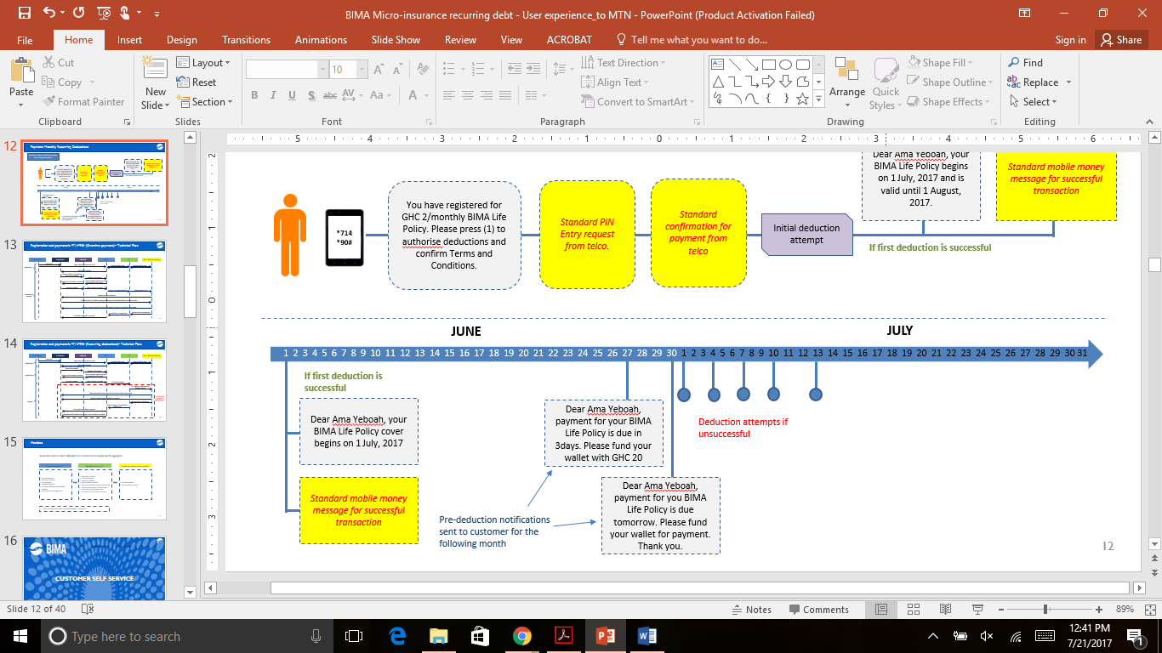

**Scenario:**

* 1st payment of the policy will have to be made within 90days of registration, otherwise policy would expire.

### Catch up Rules for MTN Mobile Money

A customer who misses payment within a month due to lack of funds in his/her wallet will receive cover for that month; he or she can miss payment for up to 6 months and still receive cover. After 6 months the customers policy lapses.

Missed payment for a month will be paid for in the following month, this will be processed separately from the original payment for the month eg. if a customer misses GHC 2 payment in January, the initial deduction attempt on the customers wallet for February will be GHC 2; if successful, then GHC 2 for January will be deducted from the customers wallet. A similar convention would occur for subsequent months (max 6 months total).

### General Rules for Tigo Cash

**One-time payment rules:**

|  |  |  |
| --- | --- | --- |
| **Payment Rule** | **Responsibility** | |
|  | **BIMA** | **Tigo** |
| 1. One push payment attempt will be made at the time of registration. Payment will be based on the price and duration of policy chosen: i.e GHC 18,12 or 6 will be deducted for the corresponding cover period |  |  |
| 1. If deduction attempt fails the customer can try again to make payments by redialing *501*5# |  |  |

**Recurring deduction rules:**

|  |  |  |
| --- | --- | --- |
| **Deduction Rule** | **Responsibility** | |
|  | **BIMA** | **TIGO** |
| 1. Deduction attempts will start on the day of registration |  |  |
| 1. A policy is only activated once payment goes through; deduction attempts in subsequent months will occur on the same date of initial registration |  |  |
| 1. On the scheduled debit date, there will be 1 deduction attempts on that day (at 9am) |  |  |
| 1. A notification to fund wallet should be sent to customer 3 days prior to the beginning of deduction attempts and on the day prior to the deduction |  |  |
| 1. Deduction attempts will occur everyday |  |  |
| 1. A failure notification would be sent to the customer after 9 days of unsuccessful deductions attempt. (With a maximum of 2 within the month) |  |  |
| 1. GHC 2 will be deducted from the customers wallet for cover for the next 30 days1 |  |  |
| 1. Deduction attempts will cease for the month once a debit (full payment) has been made from the customers wallet |  |  |
| 1. Deduction attempts will resume the following month, on the same date of registration |  |  |
|  |  |  |

1. However, subject to waiting period rules per product

### Catch up Rules for Tigo Cash

A customer who misses payment within a month due to lack of funds in his/her wallet will receive cover for that month; he or she can miss payment for up to 6 months and still receive cover. After 6 months the customers policy lapses.

Missed payment for a month will be paid for in the following month, this will be processed separately from the original payment for the month eg. if a customer misses GHC 2 payment in January, the initial deduction attempt on the customers wallet for February will be GHC 2; if successful, then GHC 2 for January will be deducted from the customers wallet. A similar convention would occur for subsequent months (max 6 months total).

## Waiting period

### Policies with one-time payment

Personal Accident

The policy will be active immediately once the transaction is approved and paid for upfront and will last for the next 3,7 or 12 months i.e. 90, 210 and 365 days. Once policy is active there will be no waiting period for renewals.

BIMA Life

The policy will be active 90 days after the transaction is approved and paid for upfront and will last for the next 3, 7 or 12 months i.e. 90, 210 and 365 days. Once policy is active there will be no waiting period for renewals.

Hospital Admission

The policy will be active 30 days after the transaction is approved and paid for upfront and will last for the next 3, 7 or 12 months i.e 90, 210 and 365 days. Once policy is active there will be no waiting period for renewals.

BIMA Doctor

The policy will be active immediately once the transaction is approved and paid for upfront and will last for the next 7 or 12 months i.e. 210 and 365 days. Once policy is active there will be no waiting period for renewals.

### Policies with payments made by recurring deduction

Personal Accident and BIMA Doctor

The policy will be active immediately once the transaction is approved and paid for by the first deduction. The policy is then monthly renewable with successful deductions in one month earning cover for the next one month (i.e. 30days). (*see deduction rules)*

Hospital Admission

The policy will be active 30 days after the transaction is approved; it is paid for upfront and will last for the next one month i.e. 30days.

BIMA Life

The policy will be active 90 days after the transaction is approved, it is paid for upfront and will last for the next one month i.e. 30days. (Scenario: If a customer registers for BIMA Life on the 1st of January, he/she will be deducted GHC 2/monthly for subsequent months but will only begin receiving cover after 90 days)

## Lapse Rules

**BIMA Life, Personal Accident and Hospital Admission:**

The above policies will lapse after 3 months of non-contributions. Deduction attempts will however continue for another 3 months totalling 6 months of deductions. If a deduction attempt is successful between the 4-6 month period, then the policy will be reinstated and the customer will have cover.

**BIMA Doctor:**

Policy will lapse if payment for the month is not made

## Customer status

### General

* If a customer is registered, details will be stored with status "Registered"
* If a customer is registered (regardless of channel) but does not pay (one-time deduction) or make first payment (for deductions) within 20 days, details shall be kept in the system but marked as non-confirmed.
* Once a customer has paid (one-time or first deduction) his status is "Active" for the duration of the policy
* A customer that has once been "Active" will not be removed from the system automatically regardless of whether they renew the policy or not
* A customer who asks to have his/her policy deactivated should be marked “Deactivated”. There should be a 30 day waiting period before the subscriber can be registered once they are deactivated.

### Payment: One-time deduction

* A customer that has once been "Active" will get the status "Expired" after the policy has expired
* Renewal will result in a prolonged duration of policy, commencing once the current policy lapses
* SMS notification is sent to the customer at the time of payment informing the customer of the end date of the policy, thus if two policies are purchased right after each other, the first will show the initial expiry date and once the second policy is paid for customer will be notified of the end date of the second policy (Example. Customer A buys 7 months and another 7 months on January 1st, 2017, SMS 1 will say expiry August 1st 2017 and SMS 2 will say expiry March 1st, 2018)

### Payment: Recurring deductions

* A customer will remain as “Active” and deduction attempts will continue to be made until a customer self-selects to deactivate the policy.
* Customers in arrears should be marked as “Lapsing”
* Customers who have lapsed should be marked as “Expired”
* Customers who have deactivated should be marked as “Deactivated”

## Registration of customers already registered

* If a customer gets registered but is already registered in the system for the same policy, then details will be updated but the history will remain for the MSISDN. If customer gets registered for a different policy then agent will be required to re-enter details of customer.
* If a customer is already registered for the same product in the system then only a renewal and a change in mode of payment can be made for the customer
* If a customer is being registered product with the same msisdn then the agent can choose to register it as an addition
* Customers can only switch one-time deducted policy values in the last month of existing cover
* Switching the payment mode from one-time deduction to recurring deduction is allowed only after the one-time deducted policy has expired.
* Switching from a recurring deduction to a one-time deduction policy is allowed. Assuming a customer switches to a one-time policy whilst having an existing recurring policy then the cover for one-time product will start in the next period. If the recurring policy is in arrears, then the cover will start immediately.

## De-registration & Deactivation

### One-time Payment

* A customer who asks to have his/her policy deactivated/deactivates policy using self service should be marked “Deactivated”. There should be a 30-day waiting period before the subscriber can be registered once they are deactivated.
* If an active one-time customer de-registers, no reminders regarding renewal will be sent and customer details removed from system at the end of the policy. The status in the system of this customer will be "Cancelled". In this case, the confirmation SMS will be: "You have been deregistered from [Product Name] however your service remains active until xx/xx/20xx. For enquries contact 0277 000 545 ".
* For non-active customers, they will receive a monthly sms stating “Your [Product] has expired. To renew contact 0277 000 545 or through the BIMA self service shortcode *714*99#”
* Customers can deregister by either contacting a BIMA call centre agent
* No refund will be made if a customer deregisters before the policy expires

### Recurring Deduction Payment

* If a non-active customer is de-registered from the product, this results in the details being removed from the system
* If an active deduction customer de-registers, no further deductions will be made, however customer details will remain in the system until the duration of earned cover is expired. The status in the system of this customer will be “Cancelled”. In this case the confirmation SMS will be “You have been deregistered from [product name] however your service remains active until xx/xx/20xx. For enquires contact 0277 000 545”.
* Customers can de-activate their recurring policy by either contacting a BIMA call centre agent or through the BIMA Self Service USSD menu
* If a customer is deducted and de-registers in the same month, then the deductions will earn cover in the next calendar month.

## Upgrade/downgrade of a policy

* Only policies with recurring deduction payment can be upgraded or downgraded
* Monthly premiums for policies will vary with corresponding cover levels
* Customers can upgrade/downgrade an existing policy by either contacting a BIMA call centre agent or through the BIMA Self Service USSD menu

## Policy renewals

* Only policies with one-time payment can be renewed
* Customers can renew an existing policy by either contacting a BIMA call centre agent or through the BIMA Self Service USSD menu
* If a policy is renewed ahead of time, the start date of the renewed policy begins when the existing policy expires.
* Customer age displayed to agents when renewing should be the “Implied age” (see footnote in section 6.1.1 for further details)

## Policy additions

* Customers who have one-time payment policies can register and pay for more policies, however this is restricted to other one-time payment policies
* Customers who have recurring payment policies can register and pay for more policies, however this is restricted to other recurring payment policies
* Customers can add to an existing policy by either contacting a BIMA call centre agent or through the BIMA Self Service USSD menu

## Crediting of wallets

* Customers can have their MTN mobile money wallets credited by BIMA (for potential payment of claims)
* This will be done my Support Team in India by the instructions of the Country Manager (via email)

# Product Registration

## Agent Registration

An agent can register a customer via USSD or web

### Agent registration via USSD

An agent can register a customer via USSD. The flow of events while registering a customer will be;

1. Agent dials short code *714*95# on mobile phone
2. Agent enters his/her BA number
3. Agent enters his/her password
4. Agent inputs the requisite details of the customer:
5. BIMA platform sends an SMS to customer to dial *714*90# (for Cash and MTN Mobile Money Users) or *501*5# (for Tigo Cash Users) to:

* Confirm the policy only (If customer pays with cash)
* Confirm the policy and make payment (if customer pays using MTN Mobile Money or Tigo Cash)

### Agent registration via Web

An agent can register a customer via web. The flow of events while registering a customer will be;

1. Agent logs in at: http://gh.bimamobile.com/bima/login/controller/login.html
2. Agent enters his/her BA number
3. Agent enters his/her password
4. Agents goes to Customer Management > Register Customer
5. Agent enters Product Name and Customers MSISDN
6. Agent inputs the requisite details of the customer:
7. Agent selects mode of payment, either Cash, MTN Mobile Money or Tigo Cash
8. MTN Mobile Money or Tigo Cash: A customer can pay via MTN mobile money or Tigo Cash depending on the customer’s mobile money wallet number. This will require a one-time pin prompt from the customer for one-time deduction or recurring deduction. (Further details under payment section)
9. Cash: A customer can pay with cash, or via transfers through MTN mobile money or Tigo Cash depending on the customer’s preference. In this scenario, the customer can transfer the funds from their mobile money wallet manually into the agent’s mobile money wallet/ BIMA’s corporate wallet.

**Mode of Payment - Cash:**

**Tigo Cash Transfer:**

1. Customer makes payment to telesales agent using the following steps:
   * + 1. Customer dials *110# (standard for Mobile Network Operator, Tigo)
       2. Customer enters agents mobile number
       3. Customer enters amount of policy
       4. Customer receives confirmation and PIN prompt
       5. Customer enters 4-digit Tigo Cash PIN code
       6. Customer receives SMS from Tigo Cash confirming transaction
       7. Agent receives an SMS from Tigo Cash confirming transaction
2. After telesales agent receives payment, he/she proceeds to register the customer. During registration (via web) the telesales agent selects Cash.
3. At close of business, the telesales agent transfers funds from his/her wallet into the BIMA Corporate wallet using *501#
4. If telesales agent fails to transfer funds by close of business, subsequent registrations done by the agent will be capped at GHC 100.

**Mode of Payment - Cash:**

**MTN Mobile Money User:**

1. Customer makes payment to agent using the following steps:
   * + 1. Customer dials *170# (standard for Mobile Network Operator, MTN)
       2. Customer opts to transfer money
       3. Customer opts to transfer to mobile money user
       4. Customer selects subscriber
       5. Customer enters agents mobile money number
       6. Customer confirms agents mobile money number
       7. Customer enters amount of policy
       8. Customer enters reference
       9. Customer receives confirmation and PIN prompt
       10. Customer enters 4-digit Mobile Money PIN code
       11. Customer receives SMS from MTN MM confirming transaction
       12. Agent receives an SMS from MTN MM confirming transaction
2. After telesales agent receives payment, he/she proceeds to register the customer. During registration (via web) the agent selects Cash.
3. At close of business, the telesales agent transfers funds from his/her wallet into the BIMA Corporate wallet
4. If telesales agent fails to transfer funds by close of business, subsequent registrations done by the agent will be capped at GHC 100.

## Customer Self – Registration

### A new customer can register for a policy using the BIMA self-service menu. This can be accessed when the customer dials the short code *714*99#

The flow of events will be:

1. Customer dials shortcode *714*99# to access self-service menu
2. Customer selects “Register for policy” on the self-service menu
3. Customer enters product to be registered from options on menu
4. Customer enters pricing option of product
5. Customer enters mode of payment i.e either Cash, Tigo Cash or MTN Mobile money
6. Customer enters their requisite details

### Customers who have existing policies can also register for new policies by dialling the short code *714*99#

The flow of events will be:

1. Customer dials short code *714*99# to access self-service menu
2. Customer selects “Add a new policy” on the self-service menu
3. Customer confirms if he/she is paying via mobile money
4. If yes, customer enters product to be registered from options on menu
5. Customer enters pricing option of product
6. Customer enters requisite details

# Confirmation and Payment Methods

## Customer payment process with cash

**User experience:**

1. Customer makes payment of the policy to a BIMA agent with cash
2. Upon receipt of cash payment, agent registers customer (as highlighted in section 6.1.2, choosing the cash option for mode of payment)
3. Customer receives SMS with details to confirm registration
4. Customer confirms registration by dialling *714*90#

## Customer payment process with mobile money – One time deduction

### MTN Mobile Money User

**User experience:**

1. Customer receives SMS with details to confirm registration
2. Customer confirms registration by dialling *714*90#
3. Customer confirms details of policy to be paid for
4. Customer enters Mobile Money PIN to authorise payment for policy
5. Customer confirms authorisation for payment of policy
6. If payment was successful, customer receives SMS from Telco and BIMA
7. If payment was unsuccessful, customer receives SMS from Telco detailing reason

**Technical flow:**

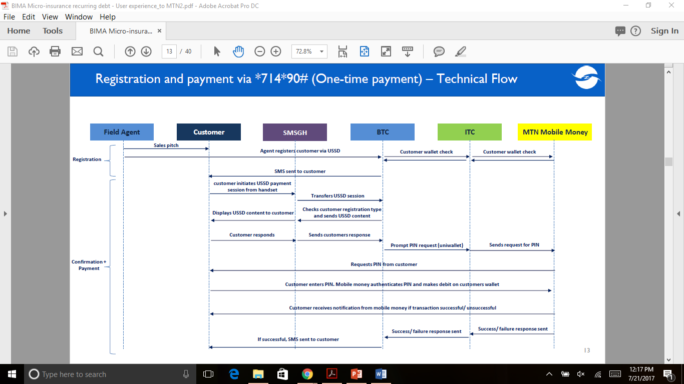

### Tigo Cash User

**User experience:**

1. Customer receives SMS with details to confirm registration
2. Customer confirms registration by dialling *501*5#
3. Customer confirms details of policy to be paid for
4. Customer reconfirms policy
5. Customer enters TIGO Cash PIN to authorise payment for policy
6. If payment was successful, customer receives SMS from Telco and BIMA
7. If payment was unsuccessful, customer receives SMS from Telco detailing reason

**Technical flow:**

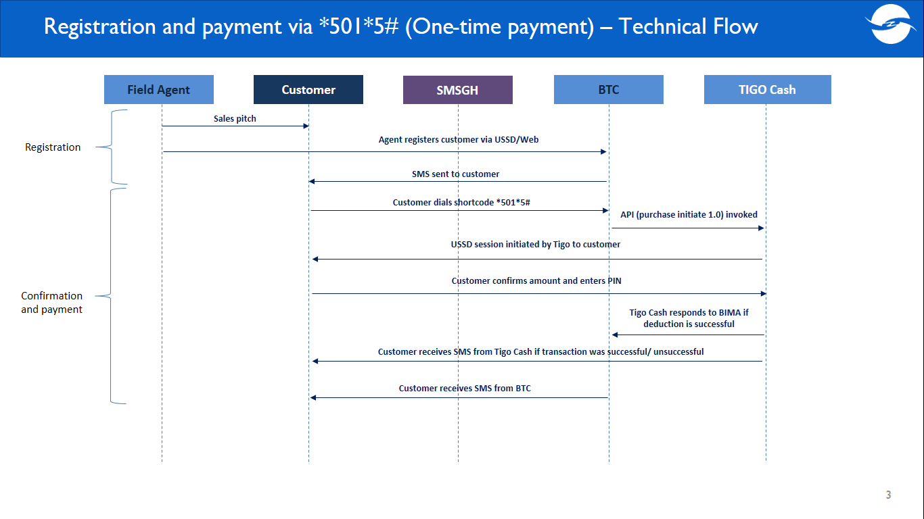

## Customer payment process with mobile money – Recurring deductions

### MTN Mobile Money User

**User experience:**

1. Customer receives SMS with details to confirm registration
2. Customer confirms registration by dialling *714*90#
3. Customer confirms details of policy to be paid for
4. Customer enters Mobile money PIN to authorise payment for policy
5. Customer confirms authorisation for payment of policy
6. If payment was successful, customer receives SMS from Telco and BIMA
7. If payment was unsuccessful, customer receives SMS from Telco detailing reason
8. Subsequent deduction attempts are made to the customers mobile money wallet (subject to deduction rules-section 2.2.1)

**Technical flow:**

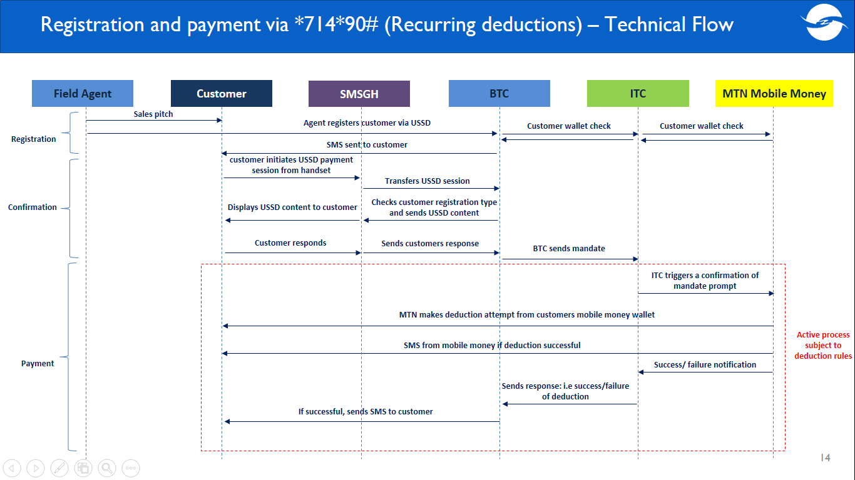

### Tigo Cash User

**User experience:**

1. Customer receives SMS with details to confirm registration
2. Customer confirms registration by dialling *501*5#
3. Customer confirms details of policy to be paid for
4. Customer reconfirms policy
5. Customer enters TIGO cash PIN to authorise payment for policy
6. Customer confirms authorisation for payment of policy
7. If payment was successful, customer receives SMS from Telco and BIMA
8. If payment was unsuccessful, customer receives SMS from Telco detailing reason
9. Subsequent deduction attempts are made to the customers mobile money wallet (subject to deduction rules - section 2.2.3)

**Technical flow:**

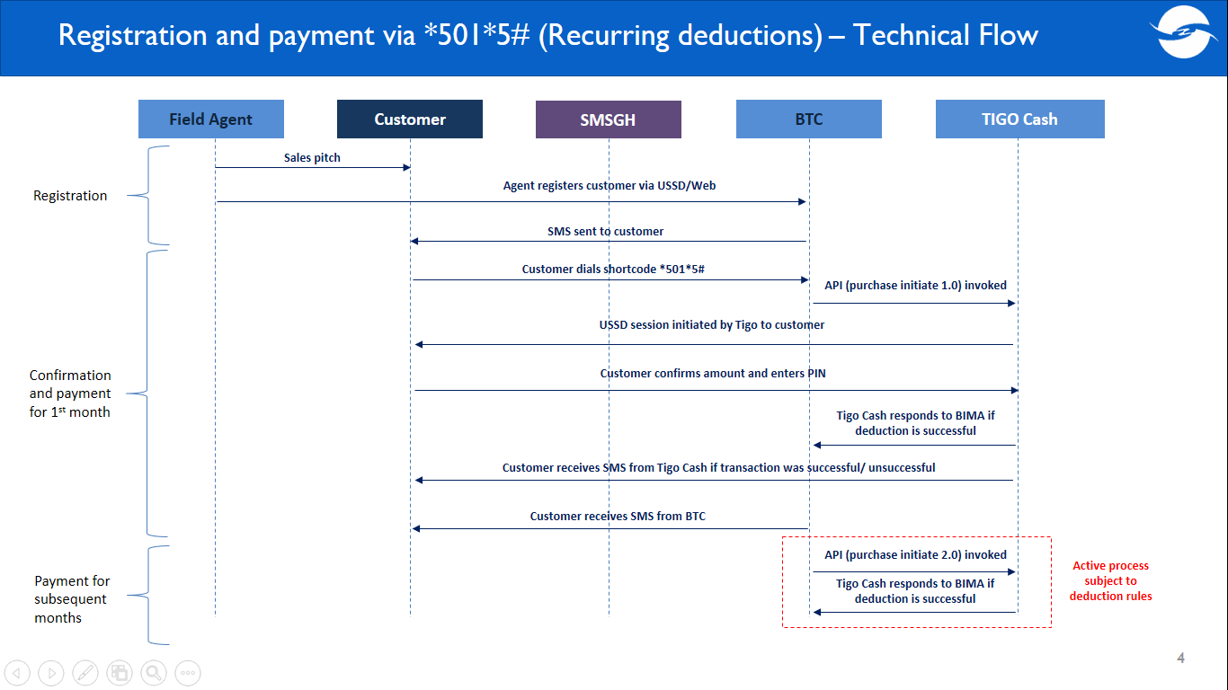

# Customer Self Service

A customer can access the BIMA self-service menu on any network by dialling the short code *714*99#

### Customer with no existing policies accessing the self-service menu

Menu will show:

1. Register for policy – Customers can register and pay for BIMA policies
2. Contact us – Shows BIMA contact details
3. How does it work? – Explains BIMA policies to customer

### Customer who has an existing policy paid for through cash accessing the self-service menu

Menu will show:

1. Check your status – Customers can check the status of their existing policy(ies)
2. Renew your policy – Customers can renew their policy using mobile money (Tigo cash or MTN mobile money)
3. Add a new policy – Customers can add and pay for other policies using mobile money (Tigo cash or MTN mobile money)
4. How does it work? – Explains BIMA policies to customer
5. Contact us – Shows BIMA contact details

### Customer who has an existing policy (one-time deduction) paid for through mobile money accessing the self-service menu

Menu will show:

1. Check your status – Customers can check the status of their existing policy(ies)
2. Renew your policy – Customers can renew their policy using mobile money (Tigo cash or MTN mobile money)
3. Add a new policy – Customers can add and pay for other policies using mobile money (Tigo cash or MTN mobile money); policies added can only be one-time deducted policies
4. How does it work? – Explains BIMA policies to customer
5. Contact us – Shows BIMA contact details

### Customer who has an existing policy (with recurring deductions) paid for through mobile money accessing the self-service menu

Menu will show:

1. Check your status – Customers can check the status of their existing policy(ies)
2. Deactivate your policy – Customers can deactivate their monthly policies
3. Add a new policy – Customers can add and pay for other policies using mobile money (Tigo cash or MTN mobile money); policies added can only be recurring deducted
4. Upgrade/downgrade your policy – Customers can upgrade or downgrade their existing policies based on price points and corresponding cover level
5. Contact us – Shows BIMA contact details

# Wording SMS/USSD communication and WEB & USSD menu

## Registration

### Bima agent registering via dashboard(web)

|  |  |  |  |  |  |
| --- | --- | --- | --- | --- | --- |
| **SI No.** | **Field** | **Type** | **Mandatory** | **Sample Values** | **Business Rule** |
|  | Product Name | Dropdown | Yes | Personal Accident | * Personal Accident * BIMA Doctor * Life Insurance * Hospital Admission * Tigo Doctor * Bima Family Health Plan |
|  | Mobile Number | Number | Yes | 054 xxx xxxx | *Entered text length must be of 10 characters* |
| **Policy Information** | | | | | |
| **1** | **Product Name** | Static | Yes | *Personal Accident* | *Static, depending on the policy chosen* |
| **2** | **Policy** | Dropdown | Yes | *GHC 18* | * *GHC 12* * *GHC 18* * *GHC 6* * *GHC 2* |
| **3** | **Mode of Payment1** | Dropdown | Yes | *MTN Mobile Money* | * *Cash* * *MTN Mobile Money* * *Tigo Cash* |
| Customer Information | | | | | |
| **4** | **First Name** | String | Yes | *Ama* | *Only alphabets, one single quote, space and hyphen* |
| **5** | **Surname** | String | Yes | *Nketiah* | *Only alphabets, one single quote, space and hyphen* |
| **6** | **Primary Mobile Number** | Number | Yes | *054 xxx xxxx* | *Entered text length must be of 10 characters* |
| **7** | **Secondary Mobile Number** | Number | Yes | *057 xxx xxxx* | *Entered text length must be of 10 characters* |
| **8** | **Does customer have a Mobile Money wallet?** | Dropdown | Yes | *Yes* | * *Yes* * *No* |
| **9** | **Mobile Money Wallet** | Number | Yes | *054 xxx xxxx* | *Entered text length must be of 10 characters, starting with 024, 054, 027, 057* |
| **10** | **Age2** | Number | Yes | *34* | *Entered text length must be of 2 characters, between 18 and 60 years inclusive* |
| **11** | **Province** | Drop down | Yes | *Ashanti* | * *Greater Accra* * *Ashanti* * *Other* |
| **12** | **Location** | Drop down | Yes | *Jamestown* |  |
| **Beneficiary Information** | | | | | |
| **13** | **First Name** | String | Yes | *Ama* | *Only alphabets, one single quote, space and hyphen* |
| **14** | **Surname** | String | Yes | *Amoah* | *Only alphabets, one single quote, space and hyphen* |
| **15** | **Age** | Number | Yes | 38 | * *Entered text length must be of 2 characters, between 18 and 60 years inclusive* |
| **16** | **Mobile Number** | Number | Yes | *054 xxx xxxx* | *Entered text length must be of 10 characters* |
| **General Information** | | | | | |
| **17** | **How did you first hear about Bima** | Dropdown | Yes | *BIMA Agent* | * *BIMA Agent* * *Friend/ Family/ Neighbour* * *Health screening* * *Roadshow/ Float* * *Radio* * *Community Leader* * *Poster/Sticker* * *Other* |

1. If GHC 2 monthly option is selected, then only Tigo Cash and MTN Mobile Money should be available.

Cash option refers to both physical cash or mobile money transfers made to agents (currently the manual function).

**Mode of payment can be changed as long as policy is unconfirmed.** Once confirmed all previously defined rules apply.

1. Age inputted will be **“Age at time or registration”,** an **“Implied age”** will be calculated by the system to reflect current age at any point in time. This will be relevant for renewals of policies should customers exceed the required age limit for cover.

### Bima agent registering via USSD

|  |  |  |
| --- | --- | --- |
| **Agent registering Customer via USSD *714*95#** | | |
| USSD to Agent | During Agent Login | Enter Agent ID |
| USSD to Agent | During Agent Login | Enter Agent Password |
| USSD to Agent | During Customer Registration | Enter Customer MSISDN |
| USSD to Agent | During Customer Registration | Enter type of policy to be registered |
| USSD to Agent | During Customer Registration | Enter pricing option |
| USSD to Agent | During Customer Registration | Enter mode of payment1 |
| USSD to Agent | During Customer Registration | Enter Customers First Name |
| USSD to Agent | During Customer Registration | Enter Customers Last Name |
| USSD to Agent | During Customer Registration | Enter Customers Age |
| USSD to Agent | During Customer Registration | Enter Customers secondary MSISDN |
| USSD to Agent | During Customer Registration | Enter Location |
| USSD to Agent | During Customer Registration | Does customer have mobile money account?2 |
| USSD to Agent | During Customer Registration | Enter customers mobile money wallet number |
| USSD to Agent | During Customer Registration | Enter Beneficiary’s First Name3 |
| USSD to Agent | During Customer Registration | Enter Beneficiary’s Last Name3 |
| USSD to Agent | During Customer Registration | Enter Beneficiary’s Age3 |
| USSD to Agent | During Customer Registration | Enter Beneficiary’s MSISDN3 |
| SMS to Agent | During Customer Registration | *[same as current message]* |
| SMS to Customer | During Customer Registration   * To customers who paid via MTN mobile money/Cash | Dear customer, to activate your [policy name], dial *714*90# now. For enquiries contact 0277 000 545. View terms and conditions here. |
| SMS to Customer | During Customer Registration   * To customers who paid via Tigo Cash | Dial *501*5# to confirm a payment of [policy amount] to [policy name] initiated on [date yyyy-mm-dd hh:ss].This will expire after 360 minutes. View terms and conditions here. |

***NB:***

1. *Mode of payment: Cash, Tigo Cash, MTN mobile money. If pricing option selected is GHC 2monthly, then the only options that should appear are Tigo Cash and MTN Mobile Money*
2. *Does customer have mobile money account? - Should appear only when mode of payment is cash*

*Customer’s Mobile money wallet number: Should appear only when mode of payment is cash and customer indicates that he/she has a mobile money account*

1. *Beneficiary’s name, age and MSISDN will appear only if customer chooses to purchase a BIMA Life policy & BIMA Personal Accident*

### Customer registering via self-service menu - USSD

|  |  |  |
| --- | --- | --- |
| **Customer self-registration via USSD *714*99#** | | |
| USSD to Customer | During Customer Self Registration | Enter type of policy to be registered |
| USSD to Customer | During Customer Self Registration | Enter pricing option |
| USSD to Customer | During Customer Self Registration | Enter mode of payment1 |
| USSD to Customer | During Customer Self Registration | Enter First Name |
| USSD to Customer | During Customer Self Registration | Enter Last Name |
| USSD to Customer | During Customer Self Registration | Enter Age |
| USSD to Customer | During Customer Self Registration | Enter secondary MSISDN |
| USSD to Customer | During Customer Self Registration | Enter Location |
| USSD to Customer | During Customer Self Registration | Enter Beneficiary’s First Name2 |
| USSD to Customer | During Customer Self Registration | Enter Beneficiary’s Last Name2 |
| USSD to Customer | During Customer Self Registration | Enter Beneficiary’s MSISDN2 |
| USSD to Customer | During Customer Self Registration | Enter Beneficiary’s Age2 |
| USSD to Customer | During Customer Self Registration | Confirm registration of [policy name] for [policy amount]?   * + 1. Yes 2. No |

1. *Mode of payment: Cash, Tigo Cash, MTN mobile money. If pricing option selected is GHC 2monthly, then the only options that should appear are Tigo Cash and MTN Mobile Money*
2. *Beneficiary’s name, age and MSISDN will appear only if customer chooses to purchase a BIMA Life policy or BIMA Personal Accident*

## Payment Methods

### Cash

|  |  |  |
| --- | --- | --- |
| **Confirmation via *714*90#** | | |
| SMS to Customer | After Customer Confirmation | Dear [Customer name], your [policy name] has been registered for [policy amount] and is valid until [policy expiry date-dd/mm/yyyy]. For enquiries call BIMA on 0277 000 545 |

### One time deduction

|  |  |  |
| --- | --- | --- |
| **Confirmation and payment via *714*90# - If payment is by MTN Mobile Money** | | |
| USSD to Customer | During Customer Confirmation | Dear [customer name], you have registered for [policy amount] [policy name]. Please press (1) to pay for your policy and accept Terms and Conditions. |
| SMS to Customer | After successful payment of policy | Dear [customer name], your [policy name] begins on [policy begin date] and is valid until [policy end date]. |

|  |  |  |
| --- | --- | --- |
| **Confirmation and payment via *501*5# - If payment is by Tigo Cash** | | |
| SMS to Customer | After successful payment of policy | Dear [customer name], your [policy name] begins on [policy begin date] and is valid until [policy end date]. |

### Recurring deductions

|  |  |  |
| --- | --- | --- |
| **Confirmation and payment via *714*90# - If payment is by MTN Mobile Money** | | |
| USSD to Customer | During Customer Confirmation | Dear [customer name], you have registered for GHC 2/monthly [policy name]. Please press (1) to authorise deductions and accept Terms and Conditions. |
| SMS to Customer | After successful first deduction of policy | Dear [customer name], your [policy name] begins on [policy begin date] and is valid until [policy end date]. |

|  |  |  |
| --- | --- | --- |
| **Confirmation and payment via *501*5# - If payment is by Tigo Cash** | | |
| SMS to Customer | After successful first deduction of policy | Dear [customer name], your [policy name] begins on [policy begin date] and is valid until [policy end date]. |

## SMSes sent to customers

### Notifications

|  |  |  |
| --- | --- | --- |
| **Notifications sent to customer – Recurring policies** | | |
| SMS to Customer   * If payment is by MTN MM or Tigo Cash | Sent to customer 3 days prior to 1st deduction attempt for the month | Dear [customer name], payment for [policy name] is due in 3 days. Please fund your wallet. |
| SMS to Customer   * If payment is by MTN MM or Tigo Cash | Sent to customer 1 day prior to 1st deduction attempt for the month | Dear [customer name], payment for your [policy name] is due tomorrow. Please fund your wallet for payment. Thank you. |

### Deduction SMS

|  |  |  |
| --- | --- | --- |
| **Notifications sent to customer – Recurring policies** | | |
| SMS to Customer  If payment is by MTN MM or Tigo Cash | Sent to customer if deduction is successful | Dear [customer name], you have paid [policy amount] for your [policy name], your policy is valid until [policy expiry date-dd/mm/yyyy]. For enquiries call BIMA on 0277 000 545 |
| SMS to Customer  If payment is by Tigo Cash | After every 9 days of unsuccessful deduction attempts | Dear [customer name], please fund your wallet for payment of your [policy name]. Thank you. |
| SMS to Customer  If payment is by MTN Mobile Money | At the end of every deduction day (i.e after 3 unsuccessful deduction attempts within the day) | Dear [customer name], please fund your wallet for payment of your [policy name]. Thank you. |

### Monthly Cover SMS

|  |  |  |
| --- | --- | --- |
| **Cover SMS sent to customer – One time policies** | | |
| SMS to Customer | Every month of cover | Dear [customer name], your [Product name] cover is [Amount] and is valid until [expiry date]. For enquiries, call BIMA customer service 0277000545. |
| SMS to Customer – for BIMA Doctor | Every month of cover | Dear [customer Name], your BIMA Doctor service is valid till [date]. Unlimited calls to a doctor! Call your doctor now on 0800 100 200 |

### Expiration SMS

|  |  |  |
| --- | --- | --- |
| **Cover SMS sent to customer – One time policies** | | |
| SMS to Customer | When a customer’s policy expires | Dear [customer name], your [product name] has expired. Call BIMA customer service on 0277000545 to renew your policy or dial short code *714*99# to renew. |

### Renewals

|  |  |  |
| --- | --- | --- |
| **Notifications sent to customer** | | |
| SMS to Customer  If payment is by MTN MM or Tigo Cash | Sent to customer if policy has been renewed | Dear [customer name], your [policy name] has been renewed for [policy amount] and is valid until [policy expiry date-dd/mm/yyyy]. For enquiries call BIMA on 0277 000 545 |
|  |  |  |

### Deactivation/Deregistration

|  |  |  |
| --- | --- | --- |
| **Notifications sent to customer – Recurring policies** | | |
| SMS to Customer  If deactivationt is by MTN MM or Tigo Cash | Sent to customer if successfully deactivates using the self service | “You have been deregistered from [product name] however your service remains active until xx/xx/20xx. For enquries contact 0277 000 545”. |
|  |  |  |

## Customer Self-Service

### Customer with no existing policies accessing the self-service menu

|  |  |  |
| --- | --- | --- |
| **Customer self-service menu - via *714*99#** | | |
| USSD to Customer | Registering for a policy | Enter product to be registered:   1. BIMA Personal Accident Policy 2. BIMA Life Policy 3. BIMA Hospital Admission Policy 4. BIMA Doctor |
| USSD to Customer | Enter price of product:   1. GHC 18 for 12 months 2. GHC 12 for 7 months 3. GHC 6 for 3 months 4. GHC 2 monthly |
| USSD to Customer | Select mode of payment1:   1. Cash 2. MTN Mobile Money 3. Tigo Cash |
| USSD to Customer | Enter first name |
| USSD to Customer | Enter last name |
| USSD to Customer | Enter secondary number |
| USSD to Customer | Enter age greater than 18 |
| USSD to Customer | Enter location |
| USSD to Customer | Enter beneficiary’s first name |
| USSD to Customer | Enter beneficiary’s last name |
| USSD to Customer | Enter beneficiary’s mobile number without country code |
| USSD to Customer | Enter beneficiary’s age |
| USSD to Customer | Confirm registration of [policy name] for [policy amount]?  1. Yes 2. No |
| USSD to Customer | Registering for a policy   * During payment of the policy | 1. If payment is a one-time deduction, please refer to wording in section 6.2.2 2. If recurring deduction, please refer to wording in section 6.2.3 |
| USSD to Customer | Contact Us | For any queries, kindly contact BIMA on 0277000545 |
| USSD to Customer | How does it work? | 1. Personal Accident 2. Life Insurance 3. Hospital Admission 4. BIMA Doctor |
| USSD to Customer | How does it work?   1. Personal Accident | **BIMA Personal Accident Policy** covers you in case of accidental death or disability from an accident. Keep your membership card safe contact 0277000545 |
| USSD to Customer | How does it work?   1. Life Insurance | **BIMA’s Life Policy** covers you and one registered family member in case of death. Keep your membership card safe. Contact 0277 000 545. |
| USSD to Customer | How does it work?   1. Hospital Admission | **BIMA Hospital Admission Policy** covers you in case of being admitted to hospital for 2 nights or more. Keep your membership card safe. |
| USSD to Customer | How does it work?   1. BIMA Doctor | **BIMA Doctor** provides unlimited telephonic doctor consultation to registered members. Doctors are available Mon-Fri 8am-5pm. Contact 0277 000 545 |

1. If GHC 2 monthly option is selected, then only Tigo Cash and MTN Mobile Money should be available

### Customer who has an existing policy paid for through cash accessing the self-service menu

|  |  |  |
| --- | --- | --- |
| **Customer self-service menu - via *714*99#** | | |
| USSD to Customer | Check your status | Your [policy name] is active until [policy end date].Your membership ID no. is [xxx] |
| USSD to Customer | Your [policy name] expired on [policy expiry date], kindly contact us on 0277 000 545 to renew. |
| USSD to Customer | Renew your policy | Mode of payment?   1. Cash 2. MTN Mobile Money 3. Tigo Cash |
| USSD to Customer | Renew your policy –  If customer selects MTN mobile money or Tigo Cash | Enter product to be renewed:   1. BIMA Personal Accident Policy 2. BIMA Life Policy 3. BIMA Hospital Admission Policy 4. BIMA Doctor |
| USSD to Customer | Do you wish to renew your [policy name] at [policy amount] for [cover period]?   1. Yes 2. No |
| USSD to Customer | Your [policy name] has been renewed. Cover begins on [policy begin date] and is valid until [policy end date] |
| USSD to Customer | Renew your policy – If customer selects Cash | To renew your policy, contact BIMA on 0277 000 545 to locate a mobile money or sales agent near you! |
| USSD to Customer | Add a new policy | Mode of payment?   1. Cash 2. MTN Mobile Money 3. Tigo Cash |
| USSD to Customer | Add a new policy   * If customer selects cash | To add a new policy, contact BIMA on 0277 000 545 to locate a sales agent near you! |
| USSD to Customer | Add a new policy   * If customer selects MTN MM or Tigo Cash | Enter product to be registered1:   1. BIMA Personal Accident policy 2. BIMA Life policy 3. BIMA Hospital admission policy 4. BIMA Doctor |
| USSD to Customer | Enter price of product:   1. GHC 18 for 12 months 2. GHC 12 for 7 months 3. GHC 6 for 3 months 4. GHC 2 monthly |
| USSD to Customer | Enter first name |
| USSD to Customer | Enter last name |
| USSD to Customer | Enter secondary number |
| USSD to Customer | Enter age greater than 18 |
| USSD to Customer | Enter location |
| USSD to Customer | Enter beneficiary’s first name |
| USSD to Customer | Enter beneficiary’s last name |
| USSD to Customer | Enter beneficiary’s mobile number without country code |
| USSD to Customer | Enter beneficiary’s age |
| USSD to Customer | Confirm registration of [policy type] for [policy amount]?  1. Yes 2. No |
| USSD to Customer | Add a new policy  During payment of the policy | Payment is a one-time deduction, please refer to wording in section 6.2.2 |
| USSD to Customer | How does it work? | 1. Personal Accident 2. Life Insurance 3. Hospital Admission 4. BIMA Doctor |
| USSD to Customer | How does it work?  Personal Accident | **BIMA Personal Accident Policy** covers you in case of accidental death or disability from an accident. Keep your membership card safe contact 0277000545 |
| USSD to Customer | How does it work?  Life Insurance | **BIMA’s Life Policy** covers you and one registered family member in case of death. Keep your membership card safe. Contact 0277 000 545. |
| USSD to Customer | How does it work?  Hospital Admission | **BIMA Hospital Admission Policy** covers you in case of being admitted to hospital for 2 nights or more. Keep your membership card safe. |
| USSD to Customer | How does it work?  BIMA Doctor | **BIMA Doctor** provides unlimited telephonic doctor consultation to registered members. Doctors are available Mon-Fri 8am-5pm. Contact 0277 000 545 |
| USSD to Customer | Contact Us | For any queries, kindly contact BIMA on 0277000545 |

1. *Present only options excluding registered policy(ies)*

### Customer who has an existing policy (one-time deduction) paid for through mobile money accessing the self-service menu

|  |  |  |
| --- | --- | --- |
| **Customer self-service menu - via *714*99#** | | |
| USSD to Customer | Check your status | Your [policy name] is active until [policy end date]. Your membership ID no. is [xxx] |
| USSD to Customer | Your [policy name] expired on [policy expiry date], kindly contact us on 0277 000 545 to renew. |
| USSD to Customer | Renew your policy | Enter product to be renewed:   1. BIMA Personal Accident Policy 2. BIMA Life Policy 3. BIMA Hospital Admission Policy 4. BIMA Doctor |
| USSD to Customer | Do you wish to renew your [policy name] at [policy amount] for [cover period]?   1. Yes 2. No |
| USSD to Customer | Your [policy name] has been renewed. Cover begins on [policy begin date] and is valid until [policy end date] |
| USSD to Customer | Add a new policy | Enter product to be registered1:   1. BIMA Personal Accident policy 2. BIMA Life policy 3. BIMA Hospital admission policy 4. BIMA Doctor |
| USSD to Customer | Enter price of product:   1. GHC 18 for 12 months 2. GHC 12 for 7 months 3. GHC 6 for 3 months |
| USSD to Customer | Enter first name |
| USSD to Customer | Enter last name |
| USSD to Customer | Enter secondary number |
| USSD to Customer | Enter age greater than 18 |
| USSD to Customer | Enter location |
| USSD to Customer | Enter beneficiary’s first name |
| USSD to Customer | Enter beneficiary’s last name |
| USSD to Customer | Enter beneficiary’s mobile number without country code |
| USSD to Customer | Enter beneficiary’s age |
| USSD to Customer | Confirm registration of BIMA Life policy for GHC 18?  1. Yes 2. No |
| USSD to Customer | Add a new policy  During payment of the policy | Payment is a one-time deduction, please refer to wording in section 6.2.2 |
| USSD to Customer | How does it work? | 1. Personal Accident 2. Life Insurance 3. Hospital Admission 4. BIMA Doctor |
| USSD to Customer | How does it work?  Personal Accident | **BIMA Personal Accident Policy** covers you in case of accidental death or disability from an accident. Keep your membership card safe contact 0277000545 |
| USSD to Customer | How does it work?  Life Insurance | **BIMA’s Life Policy** covers you and one registered family member in case of death. Keep your membership card safe. Contact 0277 000 545. |
| USSD to Customer | How does it work?  Hospital Admission | **BIMA Hospital Admission Policy** covers you in case of being admitted to hospital for 2 nights or more. Keep your membership card safe. |
| USSD to Customer | How does it work?  BIMA Doctor | **BIMA Doctor** provides unlimited telephonic doctor consultation to registered members. Doctors are available Mon-Fri 8am-5pm. Contact 0277 000 545 |
| USSD to Customer | Contact Us | For any queries, kindly contact BIMA on 0277000545 |

1. *Present only options excluding registered policy(ies)*

### Customer who has an existing policy (with recurring deductions) paid for through mobile money accessing the self-service menu

|  |  |  |
| --- | --- | --- |
| **Customer self-service menu - via *714*99#** | | |
| USSD to Customer | Check your status   * If customer has an active policy | Your [policy name] charge for May is [policy amount] and your cover for [month] is [policy cover]. Your membership ID no. is [xxx] |
| USSD to Customer | Check your status   * If customer’s policy has lapsed | Your [policy name] has lapsed. Please fund your wallet to make payment. Next debit attempt is on [debit date] |
| USSD to Customer | Deactivate your policy | Which policy do you wish to deactivate?   1. BIMA Personal Accident Policy 2. BIMA Life Policy 3. BIMA Hospital Admission Policy 4. BIMA Doctor |
| USSD to Customer | Do you wish to deactivate your [Policy name]?   1. Yes 2. No |
| USSD to Customer | Your [policy name] has been successfully deactivated. |
| SMS to Customer | Deactivate your policy | “You have been deregistered from [product name] however your service remains active until xx/xx/20xx. For enquries contact 0277 000 545”. |
| USSD to Customer | Add a new policy | Enter product to be registered1:   1. BIMA Personal Accident policy 2. BIMA Life policy 3. BIMA Hospital admission policy 4. BIMA Doctor |
| USSD to Customer | Price is GHC 2/monthly for [cover amount]. Press (1) for the next screen |
| USSD to Customer | Enter first name |
| USSD to Customer | Enter last name |
| USSD to Customer | Enter secondary number |
| USSD to Customer | Enter age greater than 18 |
| USSD to Customer | Enter location |
| USSD to Customer | Enter beneficiary’s first name |
| USSD to Customer | Enter beneficiary’s last name |
| USSD to Customer | Enter beneficiary’s mobile number without country code |
| USSD to Customer | Enter beneficiary’s age |
| USSD to Customer | Confirm registration of BIMA Life policy for GHC 2/monthly?  1. Yes 2. No |
| USSD to Customer | Add a new policy  During payment of the policy | Payment is recurring deduction, please refer to wording in section 6.2.3 |
| USSD to Customer | Upgrade/Downgrade your policy | Enter product to be upgraded/downgraded2:   1. Personal Accident 2. Life Insurance 3. Hospital Admission 4. BIMA Doctor |
| USSD to Customer | Select your new monthly policy:   1. GHC 2 2. GHC [TBD] 3. GHC [TBD] |
| USSD to Customer | Are you sure you want to upgrade to GHC [price] monthly for your [product name]?   1. Yes 2. No |
| USSD to Customer | Your [policy name] has been upgraded. Your cover is valid until [policy expiry date] |
| USSD to Customer | Contact Us | For any queries, kindly contact BIMA on 0277000545 |

1. *Present only options excluding registered policy(ies)*
2. *Only display current policies*

*BIMA currently has only GHC 2/monthly option, “Upgrade/Downgrade” option is to make provision for future policies (monthly payable) with increased price points*

# Settlement of Funds

## Liquidity Management

### Payments made with Tigo Cash

1. Tigo Cash: Applies to all payments for policies with recurring debit and one-time deduction policies (if selected during web registration)
   * + 1. All customer payments are automatically transferred to BIMA wallet 0273404028
       2. Funds are automatically reconciled (i.e customer payment, agent who registered customer)
2. Cash: Alternative payment option which only applies to GHC 6, 12 & 18 policies.
3. Customers transfer funds into agents mobile money wallet
4. Every day, agents must deposit the entire cash collected from daily sales. Thus, daily deposits = daily sales
5. The BIMA agent will transfer funds from their wallet into BIMA wallet 0273404034
6. End of day process:

The following processes are proposed:

1. Liquidity Officer downloads transaction reports for “0273404034” & “0273404028” and cleans them up. He will have the functionality on BTC to credit balances to reflect current cash balance held by the agent. This will be done on a daily basis to prevent unnecessary lockouts **– Preferred Option**
2. BTC Support downloads transaction reports for “0273404034” & “0273404028”. BTC Support will send Liquidity officer file with list of errors in transaction report to be cleaned up, whilst the error free list is uploaded (credit balances to reflect current cash balance held by the agent). Liquidity officer will send to BTC Support a cleaned up list (from the errors sent earlier) to be uploaded.
3. BIMA Ghana team (Liquidity Officer) is responsible for following up with agents to ensure that daily deposits matches daily sales.

### Payments made with MTN Mobile Money

1. MTN Mobile Money: Applies to all payments for policies with recurring debit and one-time deduction policies (if selected during web registration)
   * + 1. All customer payments are automatically transferred to BIMA bank account with UBA (with records reflecting in BIMA’s Online Vendor Account)
       2. Funds are automatically reconciled (i.e customer payment, agent who registered customer)

## Settlement when payments are made by mobile money

### Payments made with Tigo Cash

1. All funds (payments from customers/agents) are transferred into a BIMA Corporate wallet (with Tigo Cash)
2. Funds are then transferred to the BIMA settlement account on a monthly basis, as instructed by BIMA
3. At the end of the month BIMA will reconcile the total amount transferred into the bank account with an internally generated transaction report (detailing customer payments made for the month).

### Payments made with MTN Mobile Money

1. Funds are then transferred to the BIMA settlement account (with UBA) on a weekly basis by MTN
2. At the end of the month BIMA will reconcile the total amount transferred into the bank account with an internally generated transaction report (detailing customer payments made for the month).

# Dashboard and Reporting

## Reporting

BTC shall produce existing reports on policies. However, changes will be made to the following existing sections and reports:

**Agent Dashboard:** should have 2 columns – 1 for one-time deductions and the other for recurring deductions. Supervisor performance check should also include a count for confirmed GHC 2 policies (but not the total value for that price option)

1. **Premium report:** counts by policy should include all active one-time policies and all active recurring policies (ie fully paid or not lapsed for 6+ months)

**Transaction Report:**

Add “Policy type” filter. Dropdown options: ‘All,’ ‘One-time policies’ & ‘Recurring policies’

Add “mode of payment”

For Range type = Confirmed, Unconfirmed & Both

Recurring policies to be included in Transaction report.

When payment is up to date then mark recurring policy as “Confirmed” & “Expiring” for status and expiring status respectively

For Range type = expired, also include recurring policies.

When customer is in arrears but has cover (i.e. less than 3 months), mark as “Lapsing” for expiry status

If recurring policy lapses for > 3 months then mark as “Expired”

Summary daily and monthly transaction reports detailing:

Confirmed subs – Count of customers who gave their confirmations for the first time in that day or month

Deactivated subscribers – Count of customers who deactivated their policies

Fully lapsed subscribers – The count of customers for whom the policy was stopped by the system because payment did not occur

Deductions – The sum of the total amount that we have deducted from the customers in that particular day or month

1. **Liquidity report** – sales from mode of payment: MTN MM & Tigo Cash should be excluded from the agent total
2. **Other changes to BTC**
3. Include cover history (monthly payments) of customers on the dashboard with the following details:
   * 1. Month
     2. Payment
     3. Cover

## Role Management

1. The following roles can register a customer who opts to make payments on a one-time or recurring basis:
2. Team leader
3. Field agent
4. Customer service agent
5. Call centre renewal agent
6. Call centre telesales agent
7. Renewals BIMA and TIGO doctor
8. Hybrid agent
9. Hybrid team leader
10. Telesales team leader
11. Access rights for existing reports should remain the same.
12. The following roles should be able to download the transaction report:
13. Business Administrator
14. Regional Supervisor
15. The following roles can activate/register a deactivated subscriber:
    1. Business Administrator
    2. Regional Supervisor

# Contact Information

|  |  |
| --- | --- |
| **BIMA Ghana (Milvik Ghana Ltd)**  Russell Haresign: +233 57 644 0013  Harold Dansu: +233 27 664 0753  Francis Tay: +233 57 006 1287  [www.bima.com.gh](http://www.bima.com.gh)  Milvik AB  <http://www.bimamobile.com> | [russell.haresign@milvik.se](mailto:russell.haresign@milvik.se)  [harold.dansu@gh.milvik.com](mailto:harold.dansu@gh.milvik.com)  [francis.tay@gh.milvik.com](mailto:francis.tay@gh.milvik.com) |